Size For You!

# Motivation

Nearly every online clothing retailer has a section on their website devoted to sizing information, which can be a lifesaver when we’re spending money on items we can’t try on.

Before adding clothes to our virtual shopping cart, we make sure that we are clear on the store’s sizing policies. Even though I am a 6 in one brand, it doesn’t mean I am automatically a 6 in every brand. Some manufacturers simply fit larger or smaller, so I can’t rely on the dress size until I have read though the information on the website and determined which size would fit my measurements best.

# trying_on_clothes_shopping.jpg

# My personal Trick

One way that I shop online with confidence is with a sizing file on my computer. When I have success with a certain brand, I enter the brand and the size I wear into a simple Word document on my desktop. I keep a running list so that when I’m shopping online again, I can quickly bring up my file and know which size is the right one for me. Since sizes vary so widely across the board as far as fit goes, it helps to know if I am a 4 in one brand and a 6 in another. The same concept works well for shoes, which we can often snag online for cheap.

# Idea

Size For You defines your best fit in any brand. The only thing you do is add the size of any garment you own and Size For You defines the size for a desired item on the basis of pattern recognition algorithms and fuzzy logic performed on the research undertaken.

# Research

To understand the general pattern, it is necessary to have a huge research data so as to be more accurate.

For data mining we need to have a huge data set obtained from participants with different figures and different brand preferences.

For this we have two options to collect information:

* Survey
* Information entered by user in Zappo website.

A survey could like somewhat like this:

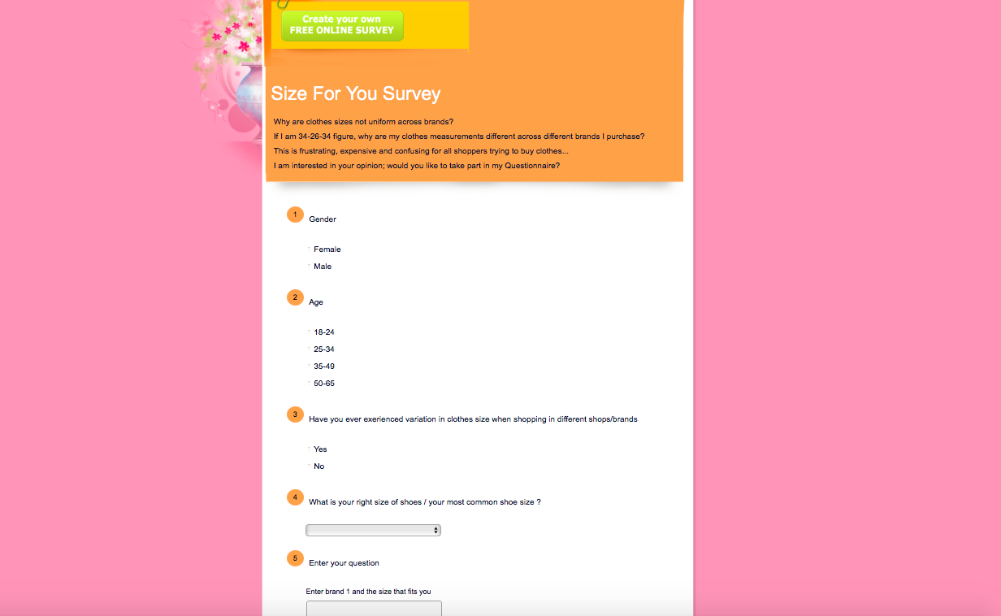

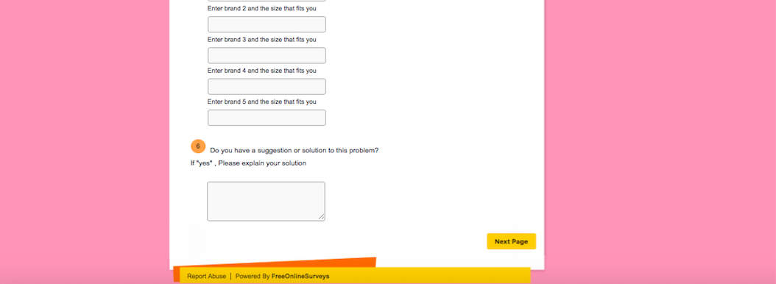

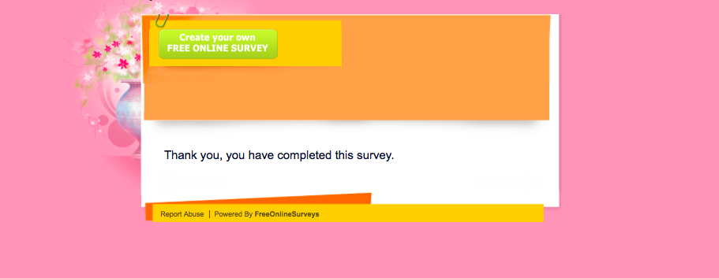

# Integration in Zappo’s Platform

When a person enters something that he is sure of is a perfect fit and knows that based on that information if he is getting a recommendation from us, he will be psychologically more satisfied and acceptable to the recommendation. User will be very happy with the service (At least I will be!).

Technologically, it is very easy to implement, its all deep learning in the backend. Using a machine learning algorithm can prove to be a great technological improvement for Zappo. In the mockup below, I have roughly designed how this feature should work. If a user clicks on “Size For You” tab, he will be directed to a screen wherein he will be asked to enter the brand and size he is already using. And then on the basis of his input and our calculations we predict the size for the user. After the good is received we can ask the customer if it was a good fit and if the response is positive, we can add this information in our database as well.

